

*Home Going Celebration of Minister Tommie L. Moore*

*Pastor James O. Bowman Sr., Presiding*

*Pastor Delphine Taylor, Minister of Ceremony*

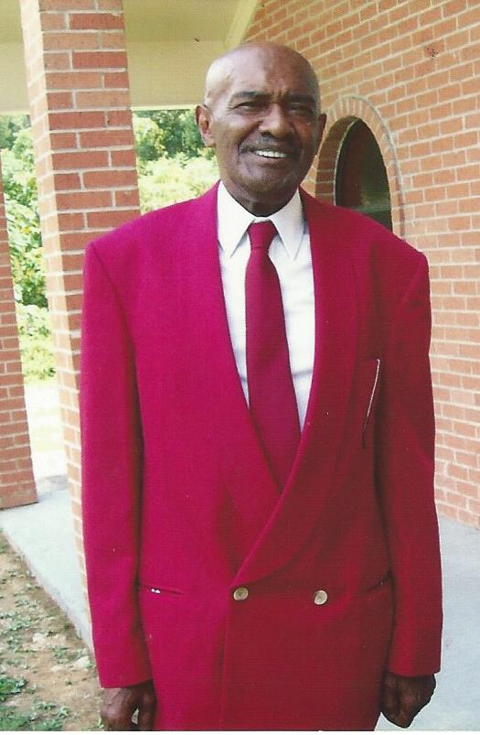

*June 30, 1940 – January 30, 2017*

*February 6, 2017 – 1:00 P.M.*

*Jefferson Funeral Home*

*800 Monroe Street*

*Tommie L. Moore was born June 30, 1940, in Vicksburg, Mississippi, to the late Gertrude Moore and Curtis Moore Sr. and raised by his Grandmother Mrs. Pearlie May Jones Walton.*

*Tommie attended Vicksburg Public Schools, in Vicksburg, Mississippi. Tommie accepted Christ in his life during his early years as a child. He was baptized St. Mary’s MB Church.*

*Tommie moved to Detroit, Michigan and where he worked in the Chrysler Auto Industry. He also was a Preacher and Pastor of a church. He also married his wife Molly, who preceded her in death.*

*Tommie recommitted his life to Christ and joined New Poplar Grove Independent Methodist in 2008. He became a faithful Associate Minister and member and involved himself in church ministries. He enjoyed the challenge of special projects, fund raisers, and participated in community outreach. He joined New Beginning Church in Christ in 2011 as an Associate Minister, and served diligently until late 2014, he departed, but landed at Pleasant Valley MB Church for a brief moment, but came back to New Beginning Church in Christ and walked faithfully until God called him home.*

*On January 30, 2017, Tommie made his transition from labor to reward, after a brief illness with a stroke. he will be greatly missed by all who loved and knew him. Lately Tommie could always be heard saying “I Won’t Complain”.*

*Precious memories will be cherished by Asberry Moore who preceded him in death, (Brother) Curtis Moore, Jr, Vicksburg, MS, Morrise Moore, Bel Camp, Maryland, Bettie L. Parker, Peral L. Mindingall, Clyde Moore, Irene Dortch, Kevin J. Moore and Sherlinda Johnson all of Detroit, Michigan. Cousins in Vicksburg, Loretta lyles, Virgie Kline, Sanda Loud, Beverly Mayfield, Michael Britton and a host of nieces and nephews.*

**

*“I have fought a good fight, I have finished my course, I have kept the faith: Henceforth there is laid up for me a crown of righteousness with the Lord, the righteous judge, shall give me at that day: and not to me only, but unto all them also that love his appearing” II Timothy 4:7-8*

*Homegoing Celebration of Minister Tommie L. Moore*

*Pastor James O. Bowman Sr., Presiding*

*Pastor Delphine Taylor, Minister of Ceremony*

Musical Prelude………………………………………………………….……

*Processional*

Musical Selection ……………………………………….….… Congregation

Scripture Readings……………………………………………………………..

*Old Testament ………………………………. Deaconess Samantha R. Anderson*

*New Testament …………………..………………………….. Deacon Dion Crump*

Prayer…………………………………………………Deacon Marshall Harris

Musical Selection ………………………………………………. Congregation

Words of Encouragement & Solo…………..……………..…Pastor Joe Harris

*Reflections (2 minutes Please)*

Obituary ……………………………………………………….…Read Silently

Acknowledgements……………………………………..Pastor Delphine Taylor

Solo……………………………………………………..Sister Betty J. Bowman

A Message of Hope………………………………………………………………

Final Glimpse Until Glory………………………W. H. Jefferson Funeral Home

*Recessional*

*Acknowledgements*

*In Grateful Appreciation…*

*The Moore Family would like to acknowledge with sincere thanks and deep appreciation your overwhelming expressions of love and the many comforting phone calls, personal visits, cards and other expressions of kindness during our season of bereavement.*

*The Family*

*Pallbearers*

Family and Friends

*Honorary Pallbearers*

Family and Friends

*Interment*

Vicksburg City Cemetery

326 Lovers Lane

Vicksburg, MS 39183

*Repast*

New Beginning Church in Christ

100 Fisher Ferry Road

Vicksburg, MS 39180

*Don’t grieve for me, I’m free.*

*I’m following the path God laid for me. I took his hand when I heard him call; I turned my back and left it all. I could not stay another day, to laugh, to love to work, to play. Tasks left undone must stay that way; I found the peace at the close of the day. If my parting has left a void, then fill it with remembered joy. A friendship shared, a laugh, a kiss, ah, yes these things I too will miss. Be not burdened with times of sorrow, I wish you sunshine of tomorrow. My life’s been full; I’ve savored much, good friends, good times, and a loved one’s touch. Perhaps my time seemed all to brief, don’t lengthen it now with undue grief, life up your hearts and share with me.*

*God wanted me now, He set me free.*

*To my Friend, God put you and I together and we started a walk that many could not see the goodness in it. No matter what man said, we trusted God and now I see the outcome of the walk. We stood fast in the liberty wherewith Christ hath made us free, we were not entangled again with the yoke of bondage from the world, we love all of God’s children. Now your walk here on earth is done and you can rest now. The Father, The Son and The Holy Spirit have you now, so rest and have fun until we meet again. Love You!*

*Your Friend and Fellow Yoke man in Christ*

*Pastor James O. Bowman, Sr.*

*I won't complain  
  
I've had some good days  
I've had some hills to climb  
I've had some weary days  
I've had some sleepless nights  
But when I look around  
And I think things over  
All of my good days  
Outweigh my bad days  
  
So I won't complain  
  
Sometimes the clouds hang low  
I can hardly see the road  
And then I ask the question  
Lord why so much pain  
But He knows what's best for me  
Although my weary eyes can't see  
  
So I'll just say thank you Lord  
I won't complain  
  
God's been so good to me  
The Lord has been so good to me  
More than this old world  
Or you could ever be  
The Lord has been so good to me  
And He dried my tears away  
And He turn all my midnights into days  
  
So I'll say thank you Lord  
I just say thank you Lord  
I'll just say thank you Lord  
I won't complain*